A

SYNOPSIS

ON

**“SlotiFy”**

SUBMITTED TO

**RAJIV GANDHI PROUDYOGIKI VISHWAVIDYALAYA**

(M.P.)



In partial fulfillment for the requirement of VIII Sem of

**BACHELOR OF TECHNOLOGY**

**IN**

**(COMPUTER SCIENCE AND ENGINEERING)**

YEAR 2020-21

SUBMITTED BY

**ASHI GUPTA(0905CS171039)**

**ASHISH RATHOD(0905CS171041)**

**DIMPLE CHAUDHARY(0905CS171055)**

**Guided BY**

Mrs. RAKHI ARORA

Asst. Professor

Deptt. of CSE & IT

ITM, Gwalior (M.P)



**DEPARTMENT OF COMPUTER SCIENCE & ENGINEERING**

INSTITUTE OF TECHONOLOGY & MANAGAMENT

GWALIOR-474001 

INSTITUTE OF TECHONOLOGY & MANAGAMENT

GWALIOR

**DEPARTMENT OF COMPUTER SCIENCE & ENGINEERING**

**CERTIFICATE**

This is to certify that Ashi Gupta(0905cs171039), Ashish Rathore(0905cs171041) and Dimple Chaudhary(0905cs171055), students of Bachelor of Technology (Computer Science & Engineering) VIII semester has developed a synopsis on SlotiFy under the guidance of Mrs. Rakhi Arora using HTML, CSS and PHP for the partial fulfilment of Bachelor of Technology (Computer Science & Engineering) and submitted a satisfactory Synopsis of the project. This work has not been submitted in part or full to this or any other university for the award of any degree or diploma to the best of my knowledge.

We wish him/ her success in the future.

Mrs. Rakhi Arora

Asst. Professor

Deptt. of CSE & IT

ITM, Gwalior (M.P.)

**Candidate Declaration**

We Ashi Gupta(0905cs171039), Ashish Rathore(0905cs171041) and Dimple Chaudhary(0905cs171055), students of Bachelor of Technology (Computer Science & Engineering) VIII semester, hereby declare that we have developed this synopsis on SlotiFy. This synopsis is developed by us under the guidance of Mrs. Rakhi Arora using PHP. We submit this synopsis report for the partial fulfilment of the VIII semester of Bachelor of Technology (Computer Science & Engineering). This work has not been submitted in part or full to this or any other university for the award of any degree or diploma to the best of our knowledge.

Ashi Gupta(0905cs171039)

Ashish Rathore(0905cs171041)

Dimple Chaudhary(0905cs171055)

INSTITUTE OF TECHONOLOGY & MANAGEMENT

GWALIOR

**DEPARTMENT OF COMPUTER SCIENCE & ENGINEERING**

**ACKNOWLEDGEMENT**

At the outset, I would like to thank my guide Mrs. Rakhi Arora (Assistant Professor), Department of Computer Science & Engineering, Gwalior for supporting to work on this project and providing me ample and valuable guidance through the course of this project.

I wish to thank Dr. Rishi Soni, HOD, Department of Computer Science & Engineering, Gwalior for his continuous moral support.

I am equally grateful to Dr. Minakshi Majumdar, DIRECTOR, ITM Gwalior for providing me all the necessary resources to carry out this project work. I would like to thank all the staff members in the Department of Computer Science & Engineering, Gwalior for their support.

Ashi Gupta(0905cs171039)

Ashish Rathore(0905cs171041)

Dimple Chaudhary(0905cs171055)

**INDEX**

|  |  |
| --- | --- |
| 1. Introduction | 2 |
| 1. Project Selection | 3 |
| 1. Project Monitoring System | 4 |
| 1. System Study | 6 |
| 1. System Analysis | 7 |
| 1. Conclusion | 12 |
| 1. Future Work | 13 |
| 1. Reference | 14 |

Introduction

**AIM**

The aim of this project is to provide and design a web-based application that allows the user to stream music. The current generation is hooked with using music-streaming apps and now is the perfect time to make music site, which will be much more. SlotiFy is an application where one can listen to music. Searching of songs according to names will be possible in this. It includes number of modules such as-User registration, User Login, Song streaming, Song searching, Create playlists, Manage profile and admin has Admin login, Add Songs, Create playlists, Adding genres, Manage role and profile.

Now more than ever, streaming services are widely used and will be used further in future, so this is like a demanding project for future .

**OBJECTIVE**

The current generation is hooked with using music streaming apps. SlotiFy is an application where one can listen to music at a platform, Search of songs. It includes several modules such as- User registration, User Login, Song streaming. Now more than ever, streaming services are widely used and will be used further in future, so this is like a demanding project for future and many updates and additions in its features can be done in future.

**VISION**

We want our users experience to be hassle free. The user can stream music without paying. SlotiFy will offer this service at a platform where you can listen to songs for free, create your playlists and fall in love with music.

We want to serve our users with best possible service and provide them the kind of comfort they want. We would also want to customize our songs as per different ages. People of all ages and backgrounds will enjoy the joyful, and refreshing environment of this site.

Project Selection

**SlotiFy** is a simple web-based system that manages music. The aim of this project is to design a web-based application that allows the user, to stream music at a platform. The system will allow user to listen, search, make playlists, browse songs etc.

The salient features of the site are as follows:

1. Free Platform
2. It's accessible to everyone.
3. Reliable user validation & checking.

" **SlotiFy** " is designed in such a way that it is as user friendly as possible. So anyone can visit the site and engage with least effort.

Project Monitoring System

**GANTT CHART**

A Gantt chart is a type of bar chart that illustrates a project schedule. Gantt charts illustrate the start and finish dates of the terminal elements and summary elements of a project. Terminal elements and summary elements comprise the work breakdown structure of the project. Some Gantt charts also show the dependency (i.e., precedence network) relationships between activities. Gantt charts can be used to show current schedule status using percent-complete shadings and a vertical "TODAY" line as shown here. Although now regarded as a common charting technique, Gantt charts were considered revolutionary when they were introduced. In recognition of Henry Gantt's contributions, the Henry Laurence Gantt Medal is awarded for distinguished achievement in management and in community service. This chart is used also in Information Technology to represent data that has been collected.

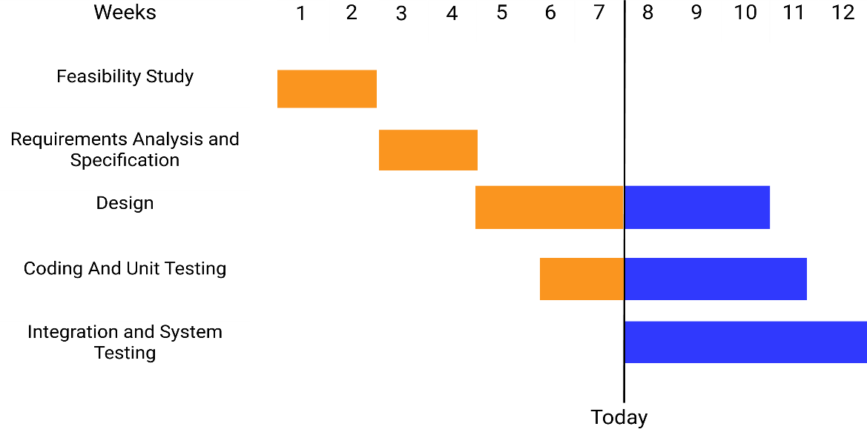

**PERT CHART**

A PERT chart is a project management tool used to schedule, organize, and coordinate tasks within a project. PERT stands for Program Evaluation Review Technique, a methodology developed by the U.S. Navy in the 1950s to manage the Polaris submarine missile program. A similar methodology, the Critical Path Method (CPM) was developed for project management in the private sector at about the same time.

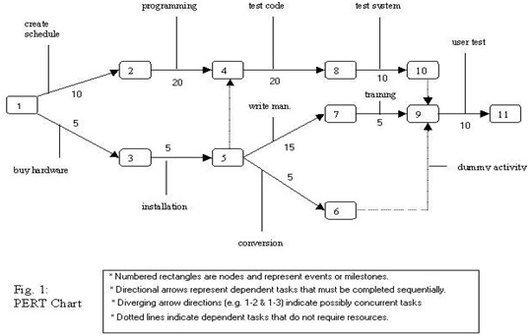

PERT chart presents a graphic illustration of a project as a network diagram consisting of numbered nodes (either circles or rectangles) representing events, or milestones in the project linked by labelled vectors (directional lines) representing tasks in the project. The direction of the arrows on the lines indicates the sequence of tasks. In the diagram, for example, the tasks between nodes 1, 2, 4, 8, and 10 must be completed in sequence. These are called dependent or serial tasks. The tasks between nodes 1 and 2, and nodes 1 and 3 are not dependent on the completion of one to start the other and can be undertaken simultaneously. These tasks are called parallel or concurrent tasks. Tasks that must be completed in sequence but that don't require resources or completion time are considered to have event dependency. These are represented by dotted lines with arrows and are called dummy activities. For example, the dashed arrow linking nodes 6 and 9 indicates that the system files must be converted before the user test can take place, but that the resources and time required to prepare for the user test (writing the user manual and user training) are on another path. Numbers on the opposite sides of the vectors indicate the time allotted for the task. The PERT chart is sometimes preferred over the Gantt chart, another popular project management charting method, because it clearly illustrates task dependencies. On the other hand, the PERT chart can be much more difficult to interpret, especially on complex projects. Frequently, project managers use both techniques.

System Study

The system study phase involves the investigation of the structure of current system, with the objective of identifying the problem and difficulties with the existing system. The major steps involved in this phase included defining the user requirements and studying the present system to verify the problem. The performance expected by the new system was also defined in this phase in order to meet the user requirements. The information gathered from various documents were analyzed and evaluated and the findings reviewed in order to establish specific system objectives.

**PROPOSED SYSTEM ALONG WITH INTENDED OBJECTIVES**

* Music streaming services will be provided at this platform.
* These services will be provided free of cost or within minimum cost.

**FEASIBILITY STUDY**

The feasibility studies are undergone as follows:

OPERATIONAL FEASIBILITY

The management & operators desire to be well acquainted with the requisite skill needed. Here most of the members in development team having technical training.It is the ease and simplicity of operation of proposed system. So, one must have little knowledge.

TECHNICAL FEASIBILITY

Technical feasibility centres on the existing computer system (hardware, software, etc.) and to what extent it can support the proposed addition. If the budget is a serious constraint, then the project is judged not feasible. In our case this does not become an obstacle.

ECONOMIC FEASIBILITY

More commonly known as Cost/Benefit Analysis. The procedure is to determine the benefits and savings that are expected from a candidate system and compare them with costs. If the benefits outweigh costs, then decision is made to design and implement the system. Considering the facts, it is becoming evident that the system will be economically feasible both for developer as well as for client’s respect.

System Analysis

**REQUIREMENT SPECIFICATION**

Requirements Specification involves the basic requirements that the system to be developed should possess. These can be broadly classified into two types.

1. Performance Requirements.

2. Functional Requirements.

Understanding the requirements specification is critical for the project’s success otherwise the system does not get developed according to the user’s wishes.

PERFORMANCE REQUIREMENTS:

1. The system should be built in a way such that it is independent of the type of database used.
2. High Scalability.
3. User friendly interface.
4. The upper limit of the time from clicking on the icon representing play to the time when the first sound can be heard is 2 seconds.
5. High maintainability.

FUNCTIONAL REQUIREMENTS:

1. A user will be able to search for a title or relating titles .
2. A user will be able to browse the song and apply filters.
3. A user will be able to listen the songs in the music catalogue.
4. A user will be able to make playlists of their favourite songs.
5. A user will be able to view, search, browse songs.

Hardware and Software Requirements

Hardware Requirements:

**SERVER SIDE**

* A server with minimum 1 GB space.
* A minimum of512 MB of RAM is required for application to work efficiently.

**CLIENT SIDE**

* Does not require any special hardware.

Software Requirements:

**SERVER SIDE**

* It requires an Apache server, PHP 7.3, PHP 7.2, PHP 7.1, PHP 7.0, PHP 5.6, MySQL, and all machine or the other goodies that the application would require.

**CLIENT SIDE**

* It just requires a latest web browser to run on client’s machine.

SYSTEM FLOWCHARTS

**LOGIN**

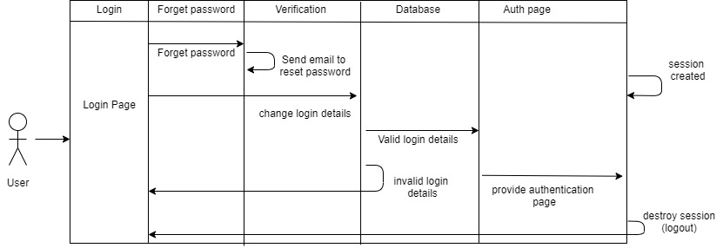

**DASHBOARD**

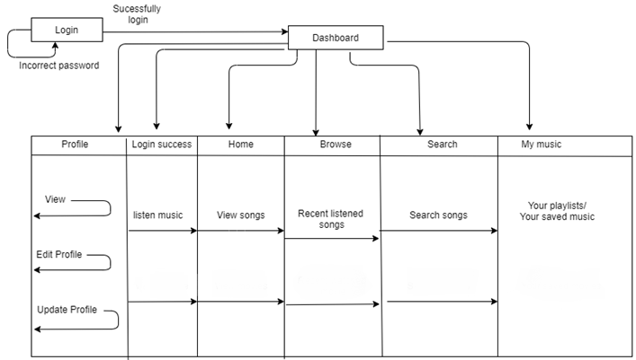

**ER DIAGRAM**

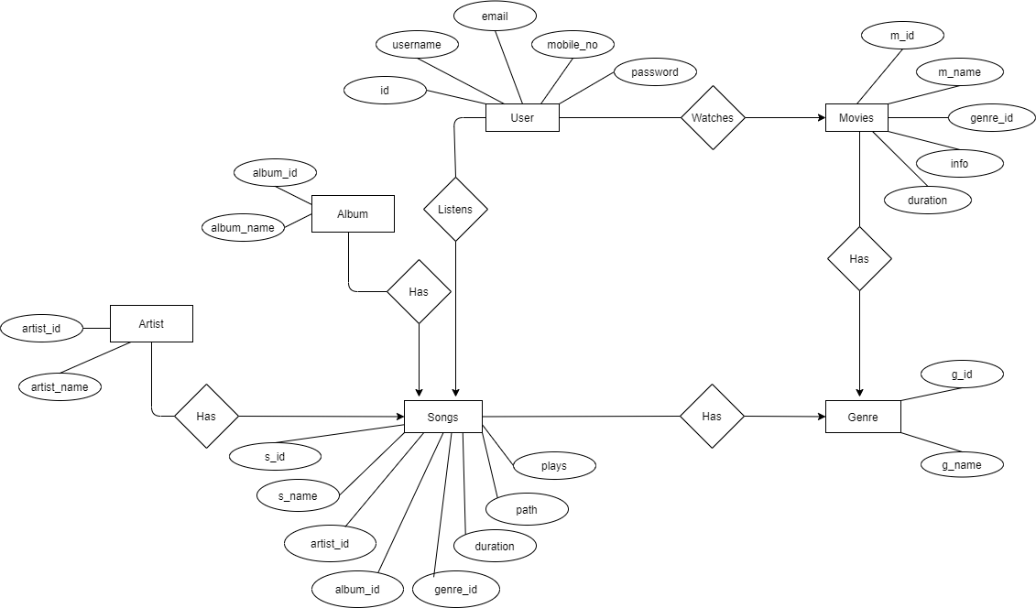

## CONCLUSION

After identifying the project background, problem statement, objectives, scope, justification and expected output, it reveals that the successful implementation of this SlotiFy will result in a more efficient music site.

* + Fast processing and immediate results
  + Navigation through the site is easy.

## This project has been a rewarding experience for all of us. We got a chance to learn new technologies, the latest trends in the IT industry and the basic of the database management systems. The Project as a whole has got benefits such as User Friendly interface and a Menu-Driven logic. We also learnt a great deal about the actual needs that goes into making a successful project.

Future Work

The transition from traditional media to digital platforms has given rise to a whole new market in which people can experience their favourite tv shows or movies from the comfort of their couch. Due to this there is a great demand of such platforms and demand of these will be furthermore increased in future. Even listening to music has become a way of relaxation for many, due to which such platforms are in demand. The advantage of this project is that this can be enhanced, modified or changed to the growing requirements of the users. We can add movies or videos too in the same platform .

## REFERENCE

Websites referred:

[www.stackoverflow.com](http://www.stackoverflow.com)

[www.w3schools.com](http://www.w3schools.com)

[www.tutorialspoint.com](http://www.tutorialspoint.com)

[www.google.com](http://www.google.com)

YouTube

Books referred:

Roger’s Pressman, Mc Graw Hill Publications

1. PHP mother sit[e @ http://php.net/.](http://php.net/)
2. PHP Manua[l @ http://php.net/manual/en/.](http://php.net/manual/en/)